**Project Documentation – Milestone 1**

**Advanced Excel & SQL**

|  |  |
| --- | --- |
| **TITLE** | SALARY SURVEY 2021 DATASET ANALYSIS |
| **Name** | PARTHASARATHI.A |
| **Course** | DADS |
| **Batch** | MAY/OFFLINE |

**TABLE OF CONTENT**

|  |  |  |
| --- | --- | --- |
| **S.NO** | **TITLE** | **PAGE NO** |
| 1. | Objective Of the Project | **3** |
| 2. | Dataset Description | **4** |
| 3. | Steps Involved | **6** |
| 4. | Key insights of the Project | **9** |
| 5. | Conclusion | **10** |

|  |  |
| --- | --- |
| **1.** | **OBJECTIVE OF THE PROJECT** |

**Project Title:**

An Analysis of Salary Survey data

The aim of this project is to explore and analyze global salary patterns using data from a large-scale salary survey.

By processing the dataset in MySQL and visualizing in Excel dashboards, the project focuses on:

Understanding how salary varies across industries, genders, and education levels.

Identifying top-paying roles and how they differ by country and experience.

Highlighting salary gaps and patterns that can help employers, job seekers, and policymakers.

|  |  |
| --- | --- |
| **2.** | **DATASET DESCRIPTION** |

The Salary Survey 2021 dataset contains detailed information about professionals from various industries and countries.

**Size**: Thousands of records with 17 attributes

**Key Attributes & Their Meaning:**

1. **Age Range** – Categorized age group of each participant.
2. **Industry** – The sector or field (e.g., IT, Healthcare, Finance).
3. **Job Title** – Official designation (e.g., Data Analyst, Manager).
4. **Clarification of Job Title** – Additional details about the role.
5. **Annual Salary** – Yearly base salary.
6. **Additional Monetary Compensation** – Bonuses, commissions, stock options, etc.
7. **Currency** – Currency in which salary is reported.
8. **Other Currency** – Custom entry if not in the standard list.
9. **Income Clarification** – Notes about salary type (e.g., commission-based).
10. **Country, State, City** – Location of work.
11. **Years of Professional Experience Overall** – Total career length.
12. **Years of Professional Experience in Field** – Years in current specialty.
13. **Highest Level of Education Completed** – Academic qualification.
14. **Gender** – Gender identity of the individual.

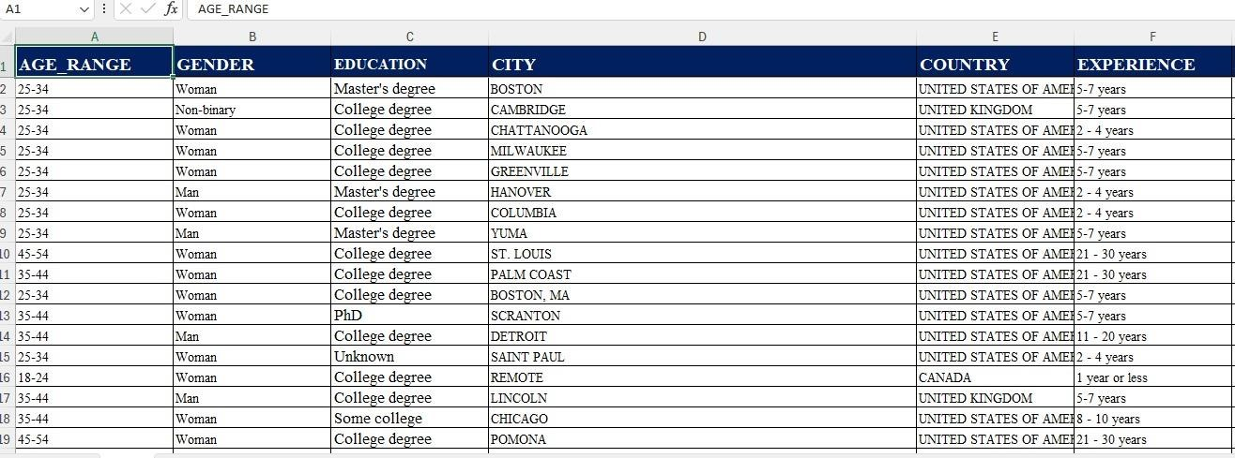

|  |  |
| --- | --- |
| **3.** | **STEPS INVOLVED** |

**Step 1 – Data Cleaning & PreProcessing :**

Missing values handled using median for numerical data and

'Unknown' for Categorical : Standardized job titles and location names. - Detected and treated salary

Outliers using IQR method. - Produced a clean dataset for analysis.

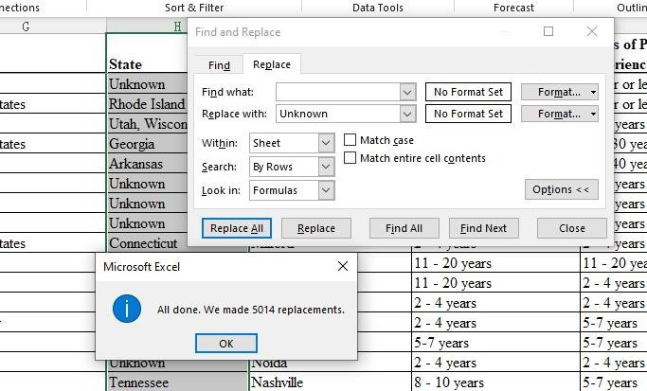

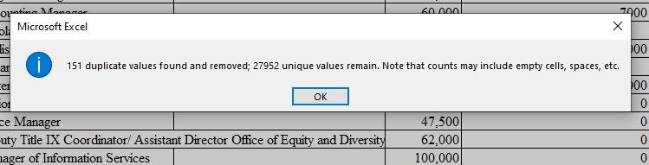

**Step 2 – Import into MySQL:**

Created 'milestone' database. - Designed 'salarysurey' table with correct data types. Imported cleaned dataset into MySQL.

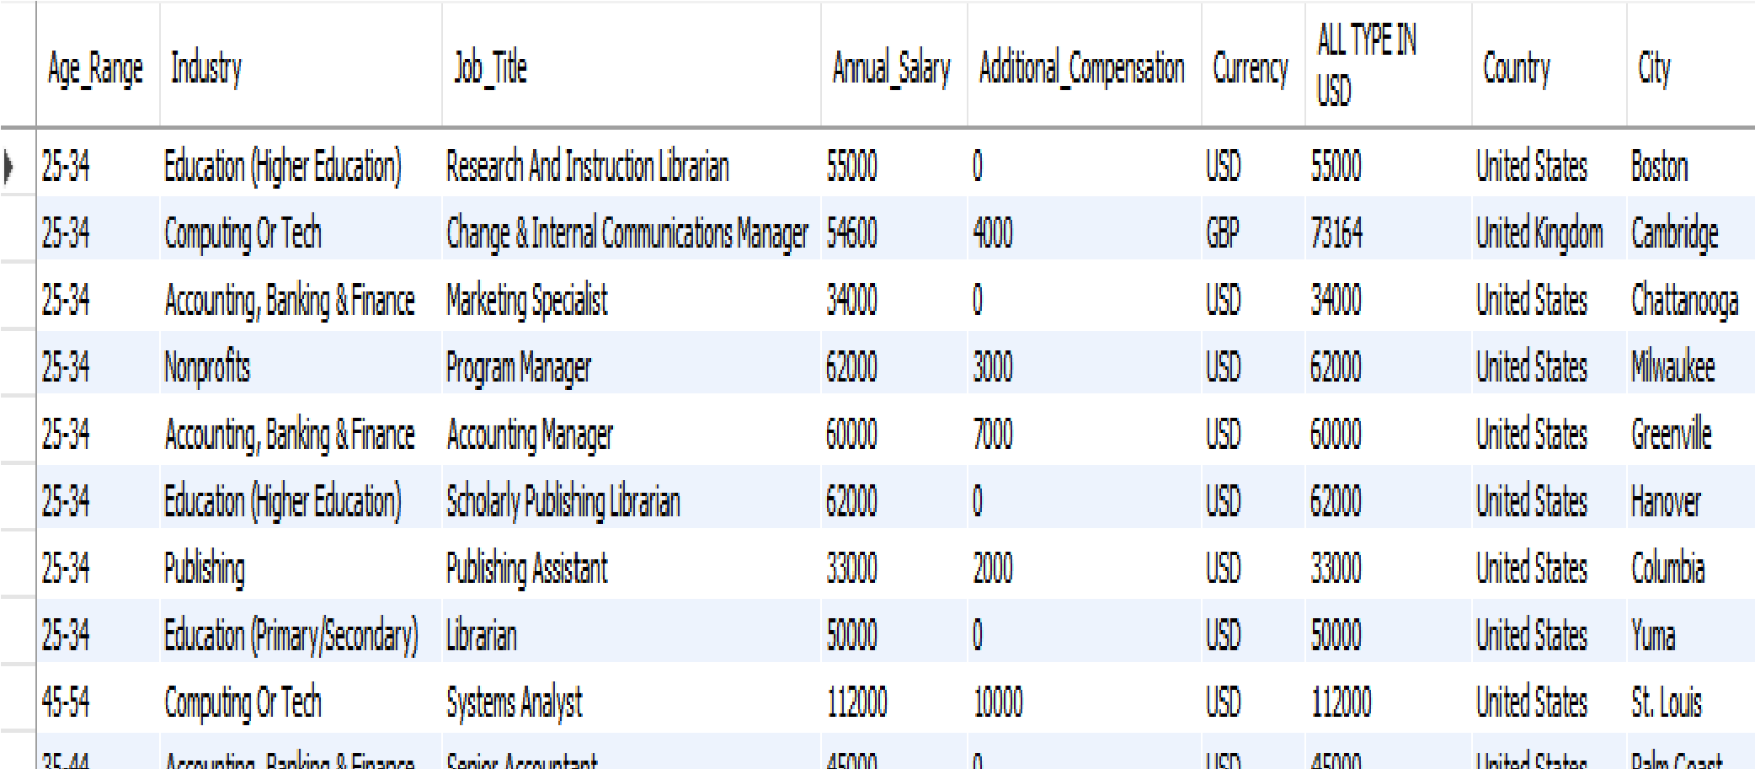

**Step 3 – SQL Query Execution:**

Run 10 queries to answer salary-related questions by industry, gender, education, and location.

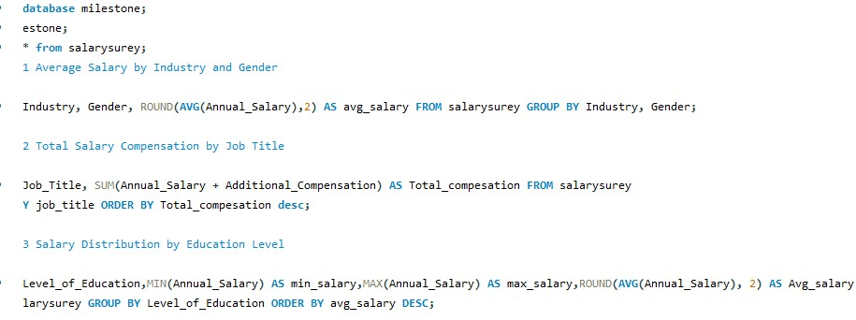

**Step 4 – Export to Excel:** Exported query results to CSV. - Imported into Excel with separate sheets.



**Step 5 – Dashboard Creation:** Created pivot tables and charts. - Added slicers for interactive filtering.

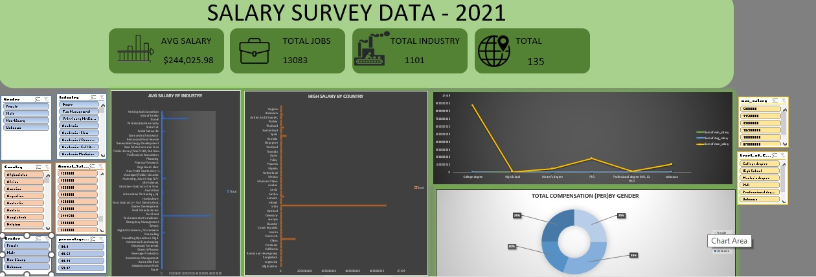

|  |  |
| --- | --- |
| **4.** | **KEY INSIGHTS OF THIS PROJECT** |

1. **Industry Influence** – Average salaries vary widely across industries, with technology and finance sectors leading.
2. **Gender Pay Gap** – Males generally earn more than females in several industries, both in base salary and additional compensation.
3. **Education Impact** – Higher education levels (Master’s, PhD) are linked to higher average salaries.
4. **Experience Effect** – Professionals with more years of experience typically earn more, especially in leadership roles.
5. **Top-Paying Roles** – Senior management and technical specialist positions dominate the highest total compensation rankings.
6. **Bonus Distribution** – A higher percentage of males receive additional monetary compensation compared to females.
7. **Geographical Differences** – Salaries differ significantly across countries and cities, influenced by cost of living and local demand.

|  |  |
| --- | --- |
| 5. | **CONCLUSION** |

The analysis shows that salary patterns are shaped by multiple factors, and looking at one factor in isolation can be misleading. Total compensation, which includes bonuses and perks, provides a clearer picture of real earnings. While advanced education and experience open the path to higher salaries, there is still room for improvement in closing gender pay gaps. Geographic salary variations highlight the importance of adjusting pay scales for local market conditions.